

European Union Carbon Border Adjustment Mechanism

Best Practices

Executive Summary
The Association of Equipment Manufacturers (AEM) is the North American-based international trade group representing nonroad equipment manufacturers and suppliers with more than 1,000 member companies and over 200 different machine forms across five diverse industry sectors. Our members design products to satisfy various safety, regulatory, durability, quality, and customer requirements to effectively operate in various extreme and demanding environments with lifespans measured in decades.

AEM recognizes the importance of identifying, addressing, and educating manufacturers, suppliers, and other industry stakeholders on important compliance issues. Carbon reporting regulations require intensive coordination throughout the entire nonroad equipment supply chain, requiring an industry wide investment of resources, time, knowledge, and expertise to effectively comply with these types of rules. To mitigate our collective compliance risks, AEM developed this best practice guidance document to help educate companies on the requirements found in the European Union’s regulation (EU) 2023/956 Carbon Border Adjustment Mechanism.
Due to the complex nature of the nonroad equipment industry’s supply chains and products, the unique requirements found in (EU) 2023/956, and the timelines companies have for reporting, AEM drafted this document to help industry stakeholders understand and comply with this new regulation. The document contains several sections:

- Assumptions
- Definitions
- Best Practices
- Examples
As the EU releases new information, or provides additional guidance, AEM will update this document to accurately represent the most up-to-date information available. For this reason, this document should be viewed as a non-exhaustive living document, representing the industry’s best understanding at the time of publication.

Disclaimer
The contents of this document are intended to offer support to AEM members by providing information on industry best practices in their efforts to comply with the EU’s CBAM regulation. This does not constitute legal advice and should not be relied upon as such. It is the sole responsibility of each individual company to determine their own compliance requirements. The AEM CBAM Template and this Best Practices Guide are intended solely to support the calculation and reporting of embedded emissions and are not intended to provide advice or recommendations on the best strategy for addressing CBAM.

Table of Contents

Executive Summary 1
Disclaimer 1
Table of Contents 2
Introduction to (EU) 2023/956 – Carbon Border Adjustment Mechanism 4
Purpose 6
Assumptions 6
Definitions 7
Official CBAM Definitions 7
CBAM Related Formulas 7
CBAM Certificate Obligation Formula 7
Expanded Cost Calculation Formula 8
Net CBAM Obligation 8
CBAM Template Definitions 8
Default Values: 10
Examples: 11
Example 1 - Input Instructions: 12
Example 2 - Input Instructions: 13
Example 3 - Input Instructions: 16
Default Versus Measured Emissions: 18
EU CBAM Resources 21

Introduction to (EU) 2023/956 – Carbon Border Adjustment Mechanism
Over the last decade, the EU has positioned itself at the forefront of addressing global climate change. The EU’s Green Deal set aggressive targets for the bloc to achieve greenhouse gas (GHG) emissions equivalent to 1990 levels by 2030 and to achieve carbon neutrality by 2050. Some of the policy tools the EU Commission employs include investments in specific industries, mandatory energy efficiency requirements, and carbon tax rules like CBAM.
The EU’s CBAM regulation functions as tariff placed on the carbon emitted during the production of specific carbon intensive goods entering the EU single market. These selected precursor materials include:
- Cement
- Iron and Steel
- Aluminum
- Fertilizers
- Hydrogen
- Electricity
The purpose of CBAM is to ensure that manufacturers do not have any financial incentives to move production of CBAM goods abroad to less stringent regulatory jurisdictions, a concept defined in the EU as ‘carbon leakage’. By pricing in a carbon tax, the EU is hoping to reduce the financial incentives various economic operators may have to move the production of these CBAM goods outside of the EU and therefore undermine the GHG reduction goals of the trading block.
The EU Parliament and Council signed the CBAM Regulation, (EU) 2023/956, into law on May 10th, 2023. On October 1st, 2023, CBAM started its transitional phase requiring importers to report their data on embedded carbon on the selected precursor materials 3 months later, January 31st, 2024. During this initial stage of the transition period, reporters were only required to report the direct and indirect emissions embedded in their products, they were not required to pay the carbon tax. Carbon values were determined based on an EU implementing regulation which gave companies a choice of reporting in three different ways:
- Full reporting according to a methodology established by the EU commission,
- Reporting based on an equivalent method, or
- Reporting based on default reference values
As various importers start to survey their supply chains, and establish their own compliance requirements, many economic operators seem to prefer the use of option 3, the default reference values. These default values allow manufacturers to meet their compliance requirements, while providing valuable time to comply with the stricter data collection requirements that start in 2026.
By law, the full implementation of CBAM, including the full reporting of a product’s embedded carbon data and the requirement to purchase CBAM certificates through the EU’s Emissions Trading System (ETS), will start on January 1, 2026. At this stage, all importers will need to collect, calculate, and report their carbon data to the EU and will not be allowed to use default values to calculate their CBAM tariff costs.
Eventually, the EU has stated they plan to include more products under the scope of CBAM. These product types may include chemicals, polymers and glass.

Purpose
The purpose of this document is to help original equipment manufacturers (OEMs) and their suppliers comply with the unique requirements of the EU’s CBAM regulation, (EU) 2023/956. This document is intended to be used in conjunction with the AEM CBAM template. The template can be found at the following website [insert website domain]

Assumptions
Equipment manufacturers build products consisting of tens of thousands of unique parts sourced from thousands of different suppliers operating in various countries around the world. The complexity and variability between these supply chain actors and the products they sell introduces many different obstacles when collecting carbon emissions data from numerous stakeholders. To ease the collective burden on industry, AEM and its member companies published this best practice guide along with the AEM CBAM Template to standardize our industry’s reporting processes and data formats. AEM believes this can simplify the reporting process, streamline data collection efforts, reduce confusion, and reduce our industry’s collective compliance risks.
To ensure that data collected by the OEMs is consistent and compatible across component types, AEM has outlined several key data formatting requirements from suppliers:
- Data collection efforts focus on requirements outlined in (EU) 2023/1773
  - Annex II - 3.16 – Steel Products
  - Annex II – 3.18 – Aluminum Products
- This document, and the template associated with the guidance found below, is intended to establish the embedded emissions from a particular facility and then apply that information to all parts (on a part-number basis) manufactured from that facility.
- Provide data on electricity consumption on a 12-month basis
- Provide a weight for every component or part sold to downstream customers
- Provide consistent and identifiable units when providing data across product types (e.g. kWh, kg, tons)
- Provide location of production facilities

NOTE: It is not a regulatory requirement to use default values. Companies may choose to use either their own data or default values. It is important to note that companies who choose to use default values will face an increasing carbon tax penalty over time. If companies choose to use their own data, they will need to verify these numbers with an independent and qualified third party.

Definitions

Official CBAM Definitions
Authorized CBAM Declarant: a person authorized by a competent authority.

Competent authority: the authority designated by each member state.

CBAM Goods: list of products identified in Annex I of (EU) 2023/956. Products listed under Annex I are regulated under CBAM.

Ton of CO₂e: means one metric ton of CO₂, or an amount of any other GHG listed in Annex I with an equivalent global warming potential.

Default value: the value, which is calculated or drawn from secondary data, which represents the embedded emissions in goods.

Direct emissions: the emissions from the product process of gods, including emissions from the production of heating and cooling that is consumed during the production processes, irrespective of the location of the production of the heating or cooling.

Embedded emissions: means direct emissions released during the production of goods and indirect emissions from the production of electricity that is consumed during the production processes, calculated in accordance with the methods set out in Annex IV of (EU) 2023/956.

Emissions: the release of greenhouse gases into the atmosphere as a result of the production of those goods.

Import: for the purposes of CBAM, importation means the introduction and free circulation of goods into the European Union.

Importer: means the person lodging a customs declaration for release for free circulation of goods in its own name and on its own behalf or, where the customs declaration is lodged by an indirect customs representative in accordance with EU law, the person on whose behalf such a declaration is lodged.

Indirect emissions: the emissions from the production of electricity, which is consumed during the production processes of goods, irrespective of the location of the production of the consumed electricity

Installation a stationary technical unit where a production process is carried out

CBAM Related Formulas

CBAM Certificate Obligation Formula
- CBAM Certificates = Specific Embedded Emissions (SEE) x Imported Quantity (tons)
Where:
- Specific Embedded Emissions (SEE) = tCO₂e per ton of product
- Imported Quantity = tons of goods imported into the EU

Expanded Cost Calculation Formula
CBAM financial obligation (€):
- CBAM Cost (€) = (SEE x Quantity) x EU ETS Carbon Price
Where:
- EU ETS Carbon Price = average auction price of EU ETS allowances (€/tCO₂e)

Net CBAM Obligation
During the definitive phase (from 2026), CBAM is phased in to mirror the phase out of free EU ETS allowances.
- Net CBAM Certificates = (See x Quantity) x CBAM Factor
Where:
- CBAM Factor reflects remaining EU ETS Free allocation
- Example (2026) CBAM Factor ~ 2.5% meaning importers pay for 2.5% of embedded emissions.

CBAM Template Definitions
Direct Emissions: the CO₂e emissions from the production process of goods, including emissions from the production of heating and cooling that is consumed during the production processes, irrespective of the location of the production of the heating or cooling.
NOTE: for the purposes of the AEM CBAM Template, the total direct emissions for a specific component or product are calculated based on the emissions generated from any fuel used during the production process of the component, product or good under consideration, as well as the emissions from fuel used during the production of the precursor materials sourced for the production of that component, product or good.
NOTE: transportation and distribution activities are not included under CBAM
Direct emissions per weight: the CO₂e emissions related to the fuel consumption during the production process summed with the direct emissions related to the production process of the precursor materials divided by the weight of the total production volume in tons.
Electricity Emissions: the CO₂e emissions generated from the electricity used during the production process. This value is calculated based on electricity usage (kWh) over a 12-month period multiplied by the carbon intensity of electricity (gCO₂/kWh) purchased from the utility servicing the manufacturing facility where the component, product, or CBAM good is produced.
Emissions (Electricity): are the same as electricity emissions.
Emissions (Fuel Usage): are the same as Fuel Emissions
Electricity Usage: The electricity usage will be the electricity purchased from the grid and used at your facility (MWh, kWh, GWh, BTU,) over a 12-month period.
NOTE: Suppliers can use different units, but they must be consistent with their units to make sure the OEMs can calculate their final values. Example – if they are powering their site with a diesel generator, then this would go to fuel consumption.
Fuel Emissions: The CO₂e emissions generated from the fuel used during the manufacturing process of a component, product or CBAM good.
Fuel Usage: This is the fuel used during the manufacturing process of a component, product, or CBAM good. Fuel usage should only relate to the manipulation of covered CBAM goods and the products and components those goods go into. Fuel use for transportation on off-site logistics is out of scope of CBAM.
NOTE: Fuel use may include, but is not exclusive to, the following fuel types: butane, Compressed Natural Gas (CNG), Liquid Natural Gas (LNG), Natural Gas, Natural Gas (100% mineral blend), Aviation spirit, aviation turbine fuel, burning oil, propane, petroleum gas, diesel (average biofuel blend or 100% mineral diesel), fuel oil, gas oil, lubricants, naphtha, petrol (average biofuel blend or 100% mineral petrol), processed fuel oils – residual oil or distillate oil, waste oils, marine gas oil, marine fuel oil, coal (industrial, electricity generation, or domestic), coking coal, petroleum coke, and other miscellaneous fuel sources.
Indirect Emissions: emissions from the production of electricity, which is consumed during the production processes of goods, irrespective of the location of the production of the consumed electricity.
NOTE: for the purposes of the AEM CBAM Template, the total indirect emissions for a specific component or product are calculated based on the emissions generated from the electricity used during the production process of the component, product or good under consideration, as well as the emissions from the electricity used during the production of the precursor materials sourced for the production of that component, product or good.
NOTE: for the purposes of determining your CBAM costs for iron and steel and aluminum, indirect emissions are not applicable.
Indirect emissions per weight: the CO₂e emissions from the production process of goods, including emissions from the production of heating and cooling that is consumed during the production processes, irrespective of the location of the production of the heating or cooling. indirect emissions divided by the total production volume.
Precursor Direction emissions: the CO₂e emissions from the production process of the precursor materials, this includes emissions from the production of heating and cooling that is consumed during the production processes, irrespective of the location of the production of the heating or cooling.
Precursor Indirect emissions: emissions from the production of electricity which is consumed during the production processes of precursor materials, irrespective of the location of the production of the consumed electricity.
Precursor Material Usage: the raw materials used in the production of complex CBAM goods that are themselves considered CBAM goods.
Precursor materials may include, but are not exclusively, iron & steel products, crude steel, direct reduced iron, pig iron, alloys – FeMn, Alloys – FeCr, Alloys – FeNi, sintered ore, hydrogen, or other supplier determined products. The unit measurements of each material should be listed in tons.
NOTE: Auto-Generated Direct and Indirect emission values in the AEM CBAM template are default values. If a supplier wants to list their own precursor materials with their own direct and indirect emission values, the template provides a custom value for them to provide this information. To accomplish this, the person who wishes to put this information into the spreadsheet would need to add the precursor material name as well as the direct and indirect emissions values to the Precursor Materials Tab in the spreadsheet.
Raw Materials Direct Emissions: the total direct CO₂e emissions from the production of precursor materials
Raw Material Indirect Emissions: the total indirect CO₂e emissions from the production of precursor materials.
Total Production Volume in tons: This is the total weight of the component, product or goods produced expressed in tons of material.

Default Values:
Default values are not uniform for a given CBAM good. The EU publishes default values that vary based on the country of origin for products with the same CN code, meaning the same part or material can have materially different default embedded emissions values depending on where it is produced.
Table 1: Example of default values for the same product from different countries of origin
Country of origin | CN code | Product (description) | 2026 default value
Indonesia | 7318 15 | Threaded screws and bolts, of iron or steel (whether or not with their nuts and washers), excluding certain categories | 9.053
Brazil | 7318 15 | Threaded screws and bolts, of iron or steel (whether or not with their nuts and washers), excluding certain categories | 2.816
India | 7318 15 | Threaded screws and bolts, of iron or steel (whether or not with their nuts and washers), excluding certain categories | 6.292
United States | 7318 15 | Threaded screws and bolts, of iron or steel (whether or not with their nuts and washers), excluding certain categories | 2.838
Because CBAM obligations are driven by embedded emissions, higher default values generally result in a higher CBAM certificate obligation (i.e., higher cost) for the same product. In addition, where an applicable CBAM default value is subject to a mark-up/penalty for use of default values, that penalty will increase over time, further increasing costs for companies that rely on defaults instead of verified, installation-specific data.
It is important to note that companies choosing to use their own emissions data should also plan for additional certification costs, as CBAM requires this information to be verified by an independent, qualified third-party entity before it can be used for reporting and, ultimately, for determining CBAM certificate obligations.
Source: to see the current CBAM default values, please see the CBAM Legislation and Guidance website, listed in the resources section at the end of this document.

Examples:
Example 1: Company A makes carbon steel, and they are based in China. Company A’s manufacturing facility uses natural gas in their production processes. The Raw materials that Company A brings in are out of scope for CBAM.
Table 2: Variables Example 1
Data Point | Value | Total | Units
Total Production Volume in Tons | N/A | 20,000 | Tons
Fuel Usage | Natural Gas | 15048254 | Cubic Meters
Electricity | China | 6920000 | kWh
Precursor Material | N/A | N/A | Tons

Example 1 - Input Instructions:
Select the Simplest – Per Weight on the AEM CBAM Template. Under this tab, data can be placed in the cells highlighted in yellow. All cells highlighted in grey will calculate values based on the information provided in the yellow cells.
In this straightforward example, the direct and indirect emissions from the various inputs will calculate based on the default values found in the Precursor, Fuels, and Electricity Tabs. If a company has different emissions or conversion rate values based on data they have on hand, we fully support making the changes to these tabs to ensure the end data is as accurate as possible.
Example 1 – CBAM Official Sheet:
The CBAM Official Sheet will calculate the final values the official importer will need regarding CBAM. This sheet will show the total specific emissions based in tCO₂e/ton.
NOTE: The example at the top mentioning carbon steel screws and nuts as well as High allow steel screws and nuts is an example provided by the EU commission.
Figure 2: Example 1 Simplest – Per Weight Tab
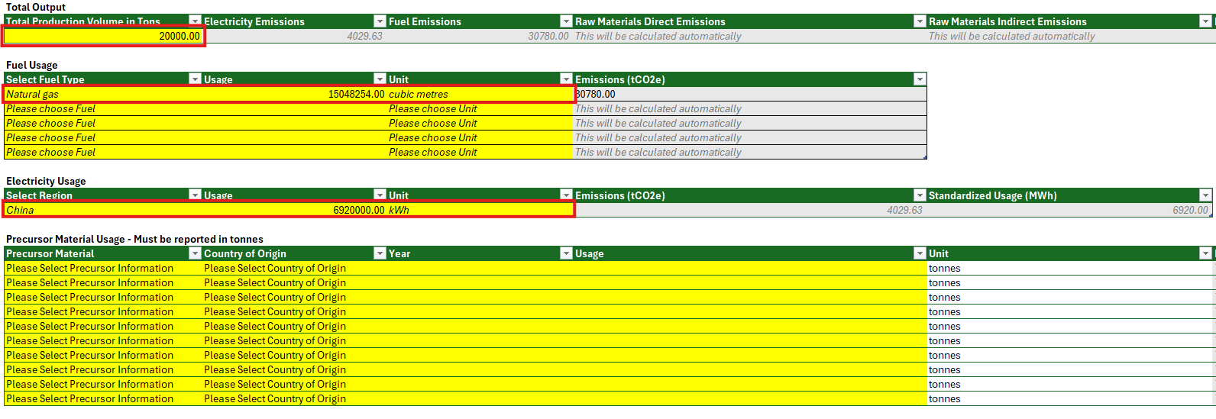
Figure 3: Example 1 - The Official CBAM Sheet
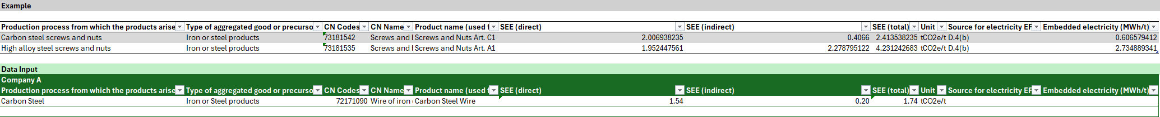
Looking at the Official CBAM Sheet in Figure 3, you can see the total Specific Embedded Emissions (SEE) of 1.74 tCO2e/t. To determine your CBAM related tax bill, you will use the cost formula listed above.
CBAM Cost (€) = (SEE × Quantity) × EU ETS Carbon Price (€75.36 per ton from the ETS price of carbon for 2026)
1.74 tCO2e/t x 20,000 tons x €75.36 = €2,622,528
Example 2: Company B makes alloy steel and is based in Illinois. This company uses industrial coal in their manufacturing process but does not have any precursor raw materials that are in scope of CBAM. The Supplier has data based on the electricity their facility consumes, and has added a custom indirect emissions factor on the Electricity Tab.
Table 3: Variables Example 2
Data Point | Value | Total | Units
Total Production Volume in Tons | N/A | 10,000 | Tons
Fuel Usage | Coal (Industrial | 6001 | Tons
Electricity | Custom (Illinois) | 20790000 | kWh
Precursor Material | N/A | N/A | Tons

Example 2 - Input Instructions:
Select the Simplest – Per Weight on the AEM CBAM Template. Under this tab, data can be placed in the cells highlighted in yellow. All cells highlighted in grey will calculate values based on the information provided in the yellow cells.
In this straightforward example, the direct and indirect emissions from the various inputs will calculate based on the default values found in the Precursor, and Fuels Tabs. In the Electricity tab, the company will fill in their own custom information for electricity consumed in Illinois (Cells E128 and F128). We fully support making changes to these tabs to ensure the end data is as accurate as possible.
Example 2 - Electricity Tab
Since the supplier is not using a default value to represent their electricity consumption, the supplier will need to edit the AEM CBAM Template to accommodate this action. To add a custom location and carbon intensity value, the template user will need to add an additional entry into the list of locations.
Figure 3: Example 2 - Electricity Tab Edits
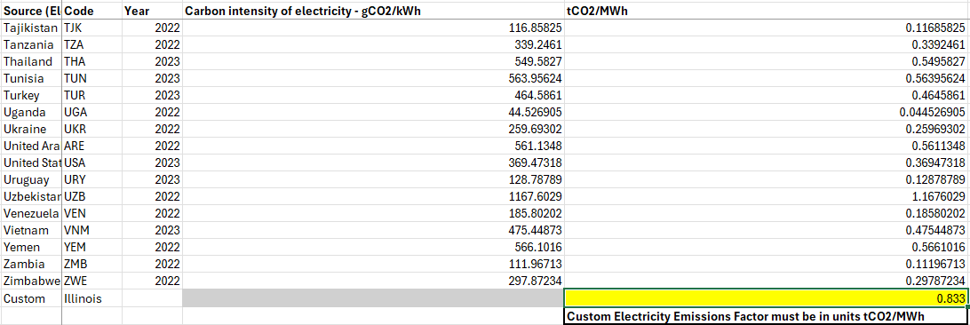
As shown in Figure 3, the user has added a new source location – ‘Custom’ along with carbon intensity values expressed in gCO₂/kWh and tCO₂/MWh. These carbon intensity tabs will need to be determined by the manufacturer and validated independently. After adding in the custom reference to the Electricity Tab, the user will need to use the term ‘Custom’ under the select region on the Electricity Usage section of the Simplest – Per Weight tab (Cell B45).
NOTE: The user does not have to use the term ‘Custom’. Any text can be chosen, provided the text is unique from others on the list.
Example 2 – CBAM Official Sheet:
The CBAM Official Sheet will calculate the final values the official importer will need regarding CBAM. This sheet will show the total specific emissions based in tCO₂e/ton.
NOTE: The example at the top mentioning carbon steel screws and nuts as well as High allow steel screws and nuts is an example provided by the EU commission.
Figure 4: Example 2 - Simplest – Per Weight Tab
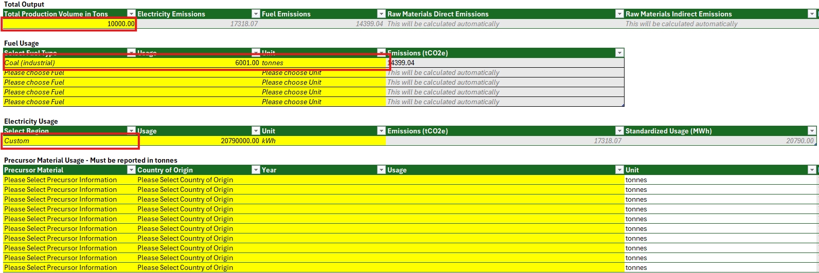
Figure 5: Example 2 - CBAM Official Sheet
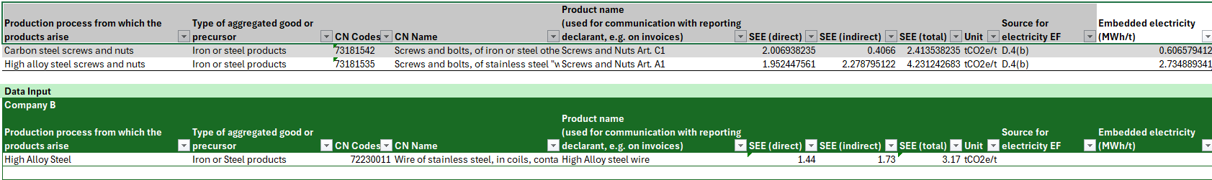
Looking at the Official CBAM Sheet in Figure 5, you can see the total Specific Embedded Emissions (SEE) of 3.17 tCO2e/t. To determine your CBAM related tax bill, you would use the cost formula listed above.
CBAM Cost (€) = (SEE × Quantity) × EU ETS Carbon Price
(3.17 tCO2e/t x 10,000 tons) x €75.36 = €2,388,912
Example 3: Company S makes Carbon Steel Screws and Allow Steel Screws and are located in Illinois. This company uses natural gas in their manufacturing process and has two precursor raw materials that are in scope of CBAM. The Supplier has data based on the electricity their facility consumes, and has added a custom carbon intensity value on the Electricity Tab.
Table 4: Variables Example 3
Data Point | Value | Total | Units
Total Production Volume in Tons | N/A | 25200 | Tons
Fuel Usage | Natural Gas | 1837.5 | Tons
Electricity | Custom (Illinois) | 5040000 | kWh
Precursor Material | Supplier Provided 1  Supplier Provided 2 | 20000  10000 | Tons

Example 3 - Input Instructions:
Select the Simplest – Per Weight on the AEM CBAM Template. Under this tab, data can be placed in the cells highlighted in yellow. All cells highlighted in grey will calculate values based on the information provided in the yellow cells.
In this straightforward example, the direct and indirect emissions from the various inputs will calculate based on the default values found in the Precursor, Fuels, and Electricity Tabs. If a company has different emissions or conversion rate values based on data they have on hand, we fully support making the changes to these tabs to ensure the end data is as accurate as possible.
Example 3 - Electricity Tab
Since the supplier is not using a default value to represent their electricity consumption, the supplier will need to edit the AEM CBAM Template to accommodate this action. To add a custom location and carbon intensity value, the template user will need to add an additional entry into the list of locations.
Figure 6: Example 3 - Electricity Tab Edits
As shown in Figure 3, the user has added a new source location – ‘Custom’ along with carbon intensity values expressed in gCO₂/kWh and tCO₂/MWh. After adding in the custom reference to the Electricity Tab, the user will need to use the term ‘Custom’ under the select region on the Electricity Usage section of the Simplest – Per Weight tab.
NOTE: The user does not have to use the term ‘Custom’. Any text can be chosen, provided the text is unique from others on the list.
Example 3 – Precursor Materials Tab
In this example, the supplier is using precursor materials that are not listed under the spreadsheets provided default list. To accurately list these materials under the Simplest – Per Weight tab, the user will need to add the precursor materials they are attempting to account for, as well as the direct and indirect emissions of those materials.
NOTE: When using custom materials, the user will need to add in their own direct emission factors. When using preexisting precursor materials and locations, the form will automatically fill in data
Figure 7: Example 3 - Precursor Material Tab
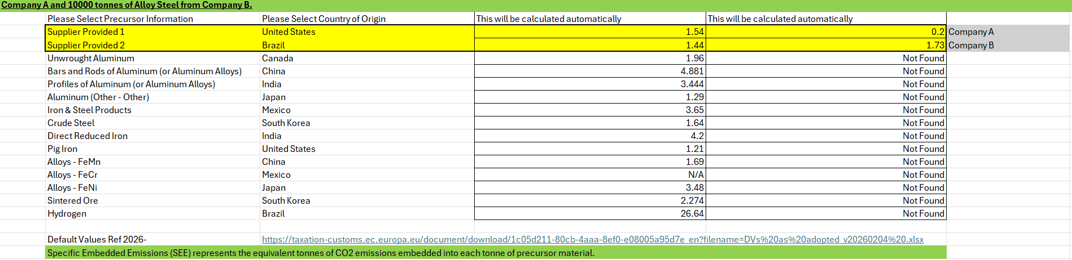
As shown in Figure 7, the user provided two different precursor materials, listed as ‘Supplier Provided 1’ and ‘Supplier Provided 2’ along with the Direct and indirect emissions for each material (Cells C3-D4). After adding these materials, the user will need to select ‘Supplier Provided 1’ and ‘Supplier Provided 2’ under the Precursor Material Usage section on the Simplest – Per Weight tab (Cells B49 and B50).
NOTE: The user does not have to use the term ‘Supplier Provided 1’. Any text can be chosen, provided the text is unique from others on the list.
Example 3 – CBAM Official Sheet:
The CBAM Official Sheet will calculate the final values the official importer will need regarding CBAM. This sheet will show the total specific emissions based in tCO₂e/ton.
Figure 8: Example 3 - Simplest – Per Weight
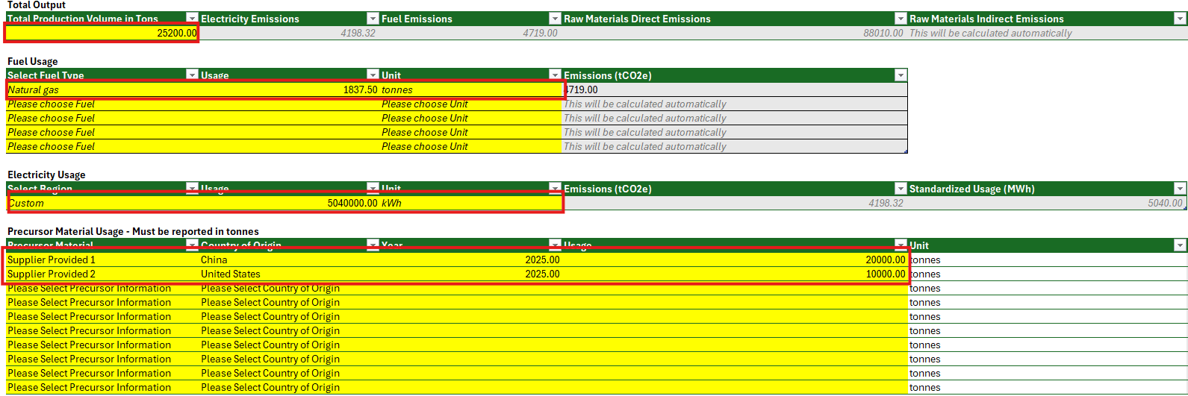
Figure 9: Example 3 - CBAM Official Sheet 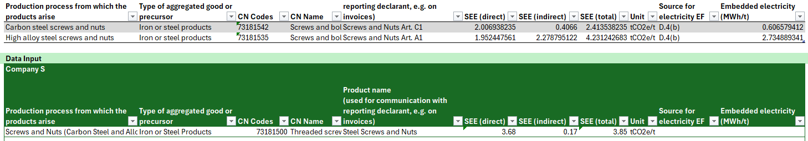
Looking at the Official CBAM Sheet in Figure 9, you can see the total Specific Embedded Emissions (SEE) of 3.854 tCO2e/t. To determine your CBAM related tax bill, you will use the cost formula listed above.
CBAM Cost (€) = (SEE × Quantity) × EU ETS Carbon Price
(3.85 x 25,200 tons) x €75.36 = €7,311,427

Default Versus Measured Emissions:
In practice, companies face a tradeoff between using EU CBAM default values and using measured or calculated emissions data. Default values can reduce the near-term data collection burden and may be useful as an initial screening approach, but they are often conservative (higher) and can increase a company’s reported embedded emissions and resulting CBAM costs, especially as penalties for relying on default values increase over time. Using company-specific emissions data can more accurately reflect actual production performance and may reduce CBAM costs, but it requires stronger internal data management (e.g., fuel, electricity, and precursor inputs) and adds time and expense for independent third-party verification before the data can be used for reporting.
Example 1 – Using Default Values over time
Companies that rely on CBAM default values as a long-term approach should anticipate increasing compliance costs over time. Default values are typically conservative and include a penalty that increases over time, meaning the same imported product can trigger a higher CBAM certificate obligation in later years even if underlying production processes have not changed.
Table 5 – Default values over time
Data Point | Value | Total | Units
Total Production Volume in Tons | N/A | 100000 | Tons
Fuel Usage | Natural Gas | 2000 | Tons
Electricity | United States | 10000000 | kWh
Precursor Material | China  United States | 20000  10000 | Tons
Using a simple template where all numbers are derived using 2025 default values, we get a SEE of .97 tCO2e/t for 2025. If we move forward in time, we will get a SEE of 1.06 tCO2e/t in 2026, a SEE of 1.14 tCO2e/t in 2027, and a SEE of 1.23 tCO2e/t in 2028. Assuming a total cost of €75.36 per ton (from the 2026 ETS price of Carbon) the costs would increase from €7,309,920 to €9,269,280 over the course of 3 years, a change of about €2 million
CBAM Cost (€) = (SEE × Quantity) × EU ETS Carbon Price
.97 tCO2e/t x 100,000 tons x €75.36 = €7,309,920
1.23 tCO2e/t x 100,000 tons x €75.36 = €9,269,280
Table 6: Cost of Defaults over time. Data taken from Table 5
Year | SEE (tCO2e/t) | Price of Carbon (per ton) | Cost
2026 | .97 | €75.36 | €7,309,920
2027 | 1.06 | €75.36 | €7,988,160
2028 | 1.14 | €75.36 | €8,591,040
2029 | 1.23 | €75.36 | €9,269,280

As shown in table 6, the costs of using defaults rise quite substantially over time. The EU introduced this mechanism to encourage importers to capture and report their own data, as opposed to using those provided by the EU commission. To avoid this, CBAM encourages companies to collect and validate their own data. Assuming all variables stay the same (Cost of carbon, the SEE for precursor materials, and total export amounts) companies using their own data will see their costs stabilize, as opposed to rise by 30% over the next three years.
Example 2: Location of Precursor Materials stay the same.
In practice, sourcing the same CBAM good from different countries can greatly increase reported embedded emissions because the EU’s default values (and, where applicable, benchmarks) are country-of-origin specific. Differences in grid carbon intensity, fuel mix, production technology, and process efficiency mean that two suppliers producing the same CN-coded product can carry materially different direct and indirect emissions profiles. As a result, shifting procurement toward higher-carbon jurisdictions, or simply using multiple countries of origin for the same input, can raise a company’s average specific embedded emissions (SEE) and, in turn, increase the number of CBAM certificates required (and associated costs) for an equivalent imported quantity, even when the physical product specifications remain unchanged.
Table 7: Default value comparisons across different locations
Country | Product CN Code | 2026  Default Value
United States | Bars and Rods of Aluminum (or Aluminum Alloys) | 2.258
Mexico | Bars and Rods of Aluminum (or Aluminum Alloys) | 1.41
India | Bars and Rods of Aluminum (or Aluminum Alloys) | 3.413
China | Bars and Rods of Aluminum (or Aluminum Alloys) | 4.881

Table 7 shows that default values for the same CBAM good can differ dramatically by country of origin. For aluminum bars and rods, the 2026 default value ranges from 1.41 tCO₂e/t (Mexico) to 4.881 tCO₂e/t (China), with the United States (2.258) and India (3.413) in between, more than a threefold spread for an otherwise comparable product. This variation can materially change a company’s reported specific embedded emissions (SEE) and therefore its CBAM certificate obligation for the same imported quantity.

EU CBAM Resources
- The Carbon Border Adjustment Mechanism eLearning module Self-paced overview of CBAM requirements and reporting expectations.
- EU CBAM Landing Page European Commission overview page with high-level CBAM background, scope, and key updates.
- Regulation (EU) 2023/956 CBAM Legal Text Authoritative CBAM regulation text describing scope, obligations, and timelines.
- Regulation (EU) 2023/1773 Implementation Regulation Implementing rules for the transitional period, including reporting methodology and default values (see Annex VIII).
  - includes listed default values in Annex VIII
- CBAM Communication Template Sample outreach language importers can use to request CBAM emissions data from suppliers.
- Guidance Document on CBAM Implementation for Importers of Goods into the EU Step-by-step Commission guidance for importers on transitional reporting, including practical examples and FAQs references.
  - (See section 5.6, Pg. 43/98)
- EU CBAM FAQ Consolidated Q&A from the European Commission addressing common CBAM compliance questions.
- National Indirect Emissions factors Reference dataset for country-level electricity carbon intensity that can support indirect emissions calculations.
- Regional Indirect Emissions factors from US EPA US EPA emission factors reference for estimating emissions from fuels and electricity by region.
- Carbon Intelligence Third-party emissions factor database that may help benchmark or screen parts when primary data is unavailable.
- Sustainability Indicators Report 2025 - worldsteel.org Industry benchmarking for steel sector sustainability metrics, including historical carbon intensity context.

https://eur-lex.europa.eu/eli/reg/2023/956/oj
https://eur-lex.europa.eu/eli/reg_impl/2023/1773/oj
https://eur-lex.europa.eu/eli/reg/2023/956/oj
CBAM Legislation and Guidance - Taxation and Customs Union

